

**The Tableau HR Scorecard: Measuring Success in Talent management**

**Introduction:**

**Overview:**

Introducing the topic of measuring success in talent management within the context of Human Resources (HR) is crucial for organizations seeking to optimize their workforce. Talent management is at the core of HR's responsibilities, encompassing recruitment, training, development, and employee engagement. In this introduction, you can emphasize the role of HR in shaping an organization's talent strategy and highlight the significance of effective measurement as a tool for continuous improvement. Mentioning key HR-specific metrics, such as cost-per-hire, time-to-fill positions, and the impact on organizational culture, can help set the stage for a deeper exploration of how HR professionals can measure and enhance talent management success.

**Purpose:**

1**. Performance Evaluation**: It allows organizations to assess the Effectiveness of their talent management strategies and programs.

2**. ROI Assessment**: Helps in determining the return on investment in hiring, developing, and retaining employees.

3. **Strategic Alignment**: Ensures that talent management efforts are aligned with the organization's strategic goals and objectives.

4**. Identifying Gaps**: Pinpoints areas where talent management needs improvement, such as in recruitment, training, or succession planning.

5. **Employee Development**: Assists in identifying high-potential employees and areas for their development.

6**. Retention**: Helps in understanding factors that contribute to employee retention and engagement.

7**. Succession Planning**: Identifies potential future leaders and ensures a pipeline of talent for key roles.

8. **Continuous Improvement**: Encourages ongoing refinement of talent management strategies for better results.

9**. Compliance**: Ensures that talent management practices comply with legal and ethical standards.

Overall, measuring success in talent management is essential for optimizing an organization's human capital, enhancing its competitiveness, and achieving long-term success.

**Milestone 1:**

**Problem Definition & Design Thinking:**

**Empathy Map:**

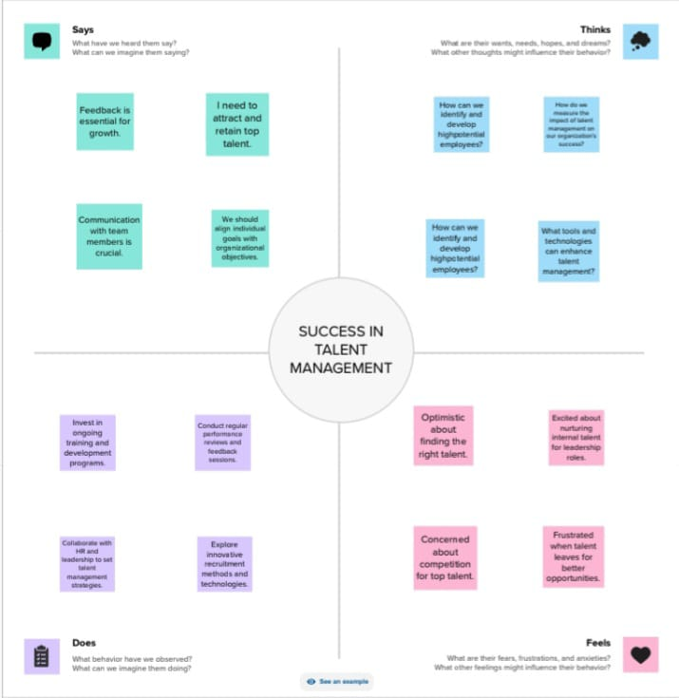

LINK:

<file:///C:/Users/ADMIN/Downloads/EMPATHY%20MAP%201.pdf>

**Ideation and Brainstorming:**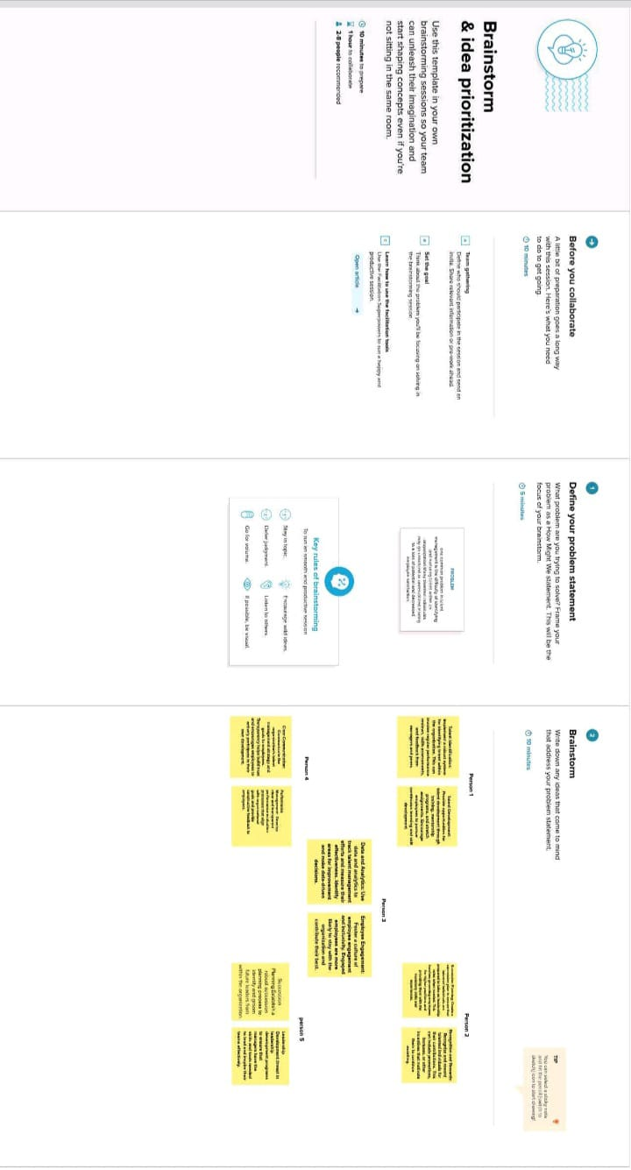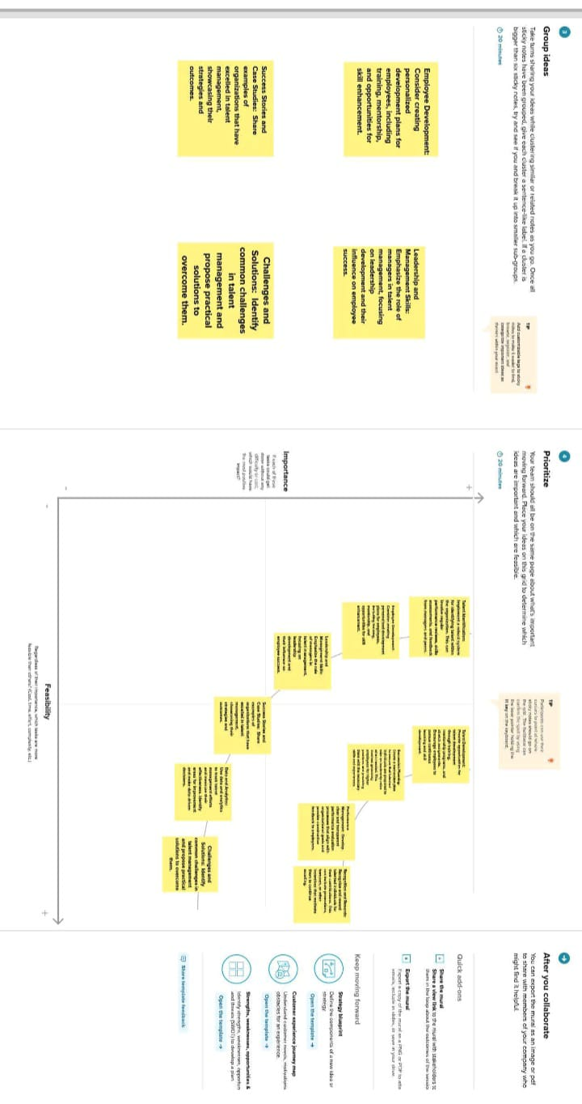

**LINK:**

**file:///C:/Users/ADMIN/Downloads/BRAINSTORMING.pdf**

**Result:**

Data collection is the process of gathering and measuring information on variables of interest, in an established systematic fashion that enables one to answer stated research questions, test hypotheses, and evaluate outcomes and generate insights from the data.

**Activity1:**

Collect the dataset Download the dataset [**https://drive.google.com/file/d/1TQLqjUgSthNTeM2_XRCqAwbrGChk-M5I/view?usp=sharing**](https://drive.google.com/file/d/1TQLqjUgSthNTeM2_XRCqAwbrGChk-M5I/view?usp=sharing)

**Activity 1.1:**

**Understand the data**

Data contains all the Meta information regarding the columns described in the CSV files. We have provided 1 CSV file: The Tableau HR Scorecard: Measuring Success in Talent Management

**Column Description for the Tableau HR Scorecard: Measuring Success in Talent Management:**

1. **Attrition**- It represents the number of people leaving the organization.

2. **Department**- It represents the employees working in different types of department 3. Education Field- It represents the employees working in the organization from different education fields.

4**. Gender**- It represents the gender of employees working in the organization.

5. **Job Role**- It represents the job role of the organization.

6**. Marital Status**- It represents whether the employees working in the company are married or not.

7**. Over time**- It represents the employees working overtime or not.

8**. Over 18-** It represents the employees working in the company who are above 18.

9**. Age**- It represents the age of the company.

10**. Distance from home**- It represents the distance of the residence of the employees from the company.

11**. Education**- It represents the qualification of the employees.

12**. Employee count**- It represents the number of employees in the company.

13**. Job satisfaction**- It represents the job satisfaction of the employees.

14**. Monthly income**- It represents the monthly income of the employees working in the organization.

15**. Percent salary hike**- It represents the percentage of salary hike of the **rating**- It represents the performance rating of the employees according to their work.

17**. Standard hours**- It represents the standard hours of work.

18**. Years in current role**- It represents the number of years worked at the current profile.

**Activity 2: Connect Dataset with Tableau**

Reference video link: [**https://drive.google.com/file/d/1NZ_h0S7V4O8it2oSyaEmTp6rgYCS29WY/view?usp=sharing**](https://drive.google.com/file/d/1NZ_h0S7V4O8it2oSyaEmTp6rgYCS29WY/view?usp=sharing)

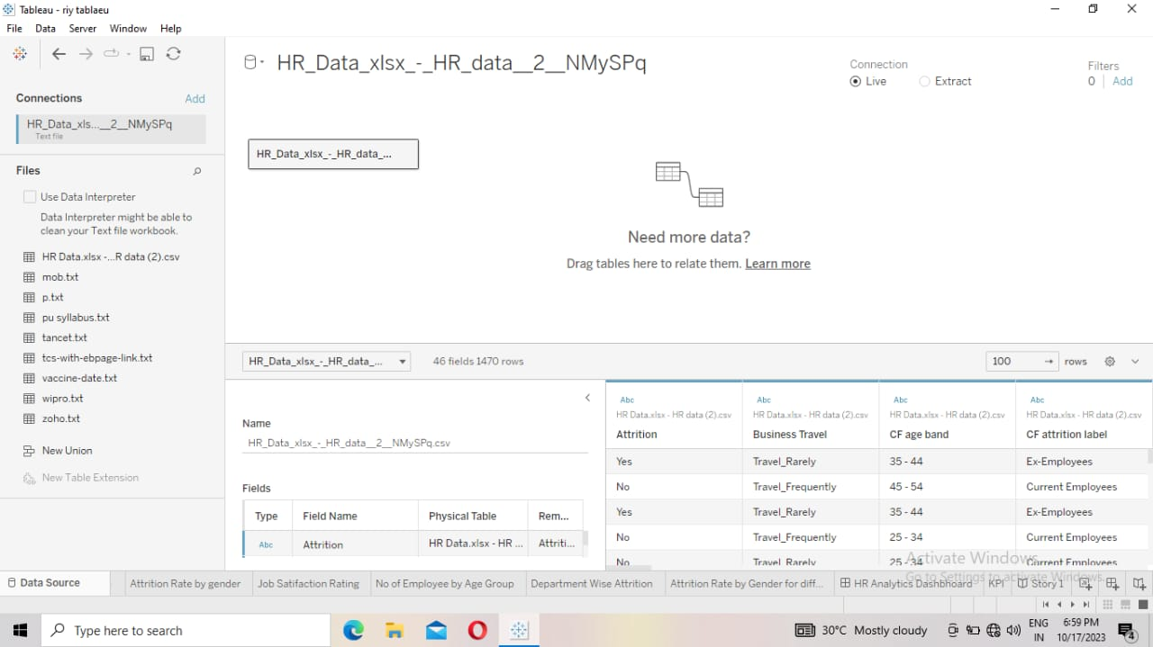

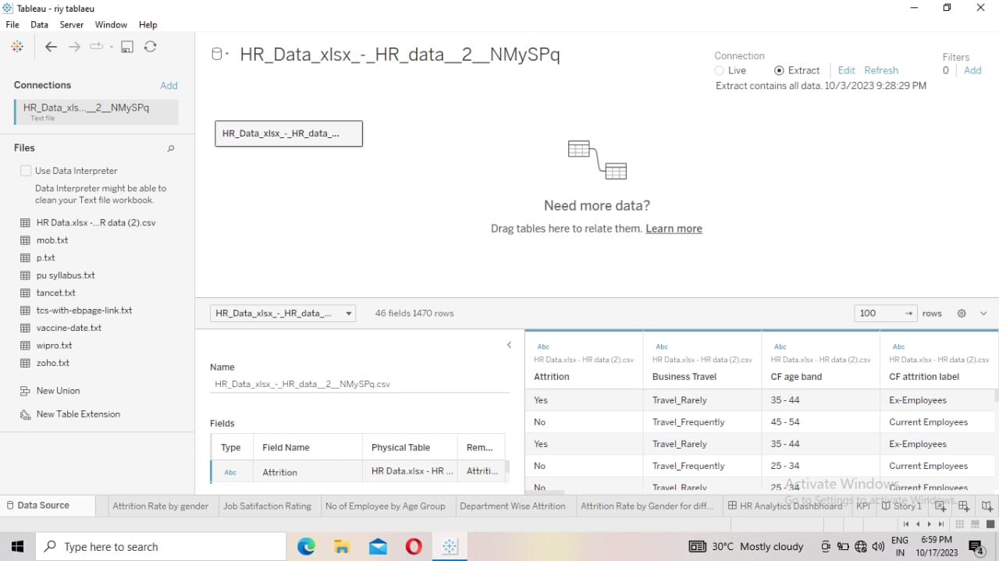

**MILESTONE 3:** **Data Preparation**

Prepare the Data for Visualization Preparing the data for visualization involves cleaning the data to remove irrelevant or missing data, transforming the data into a format that can be easily visualized, exploring the data to identify patterns and trends, filtering the data to focus on specific subsets of data, preparing the data for visualization software, and ensuring the data is accurate and complete. This process helps to make the data easily understandable and ready for creating visualizations to gain insights into the performance and efficiency

**MILESTONE 4: Data Visualization**

Data visualization is the process of creating graphical representations of data in order to help people understand and explore the information.

**Activity 1: No of Unique Visualizations**

The number of unique visualizations that can be created with a given dataset.

**Activity 1.1:**

**Create the graph on the tableau Book 1**

**Department wise Attrition**

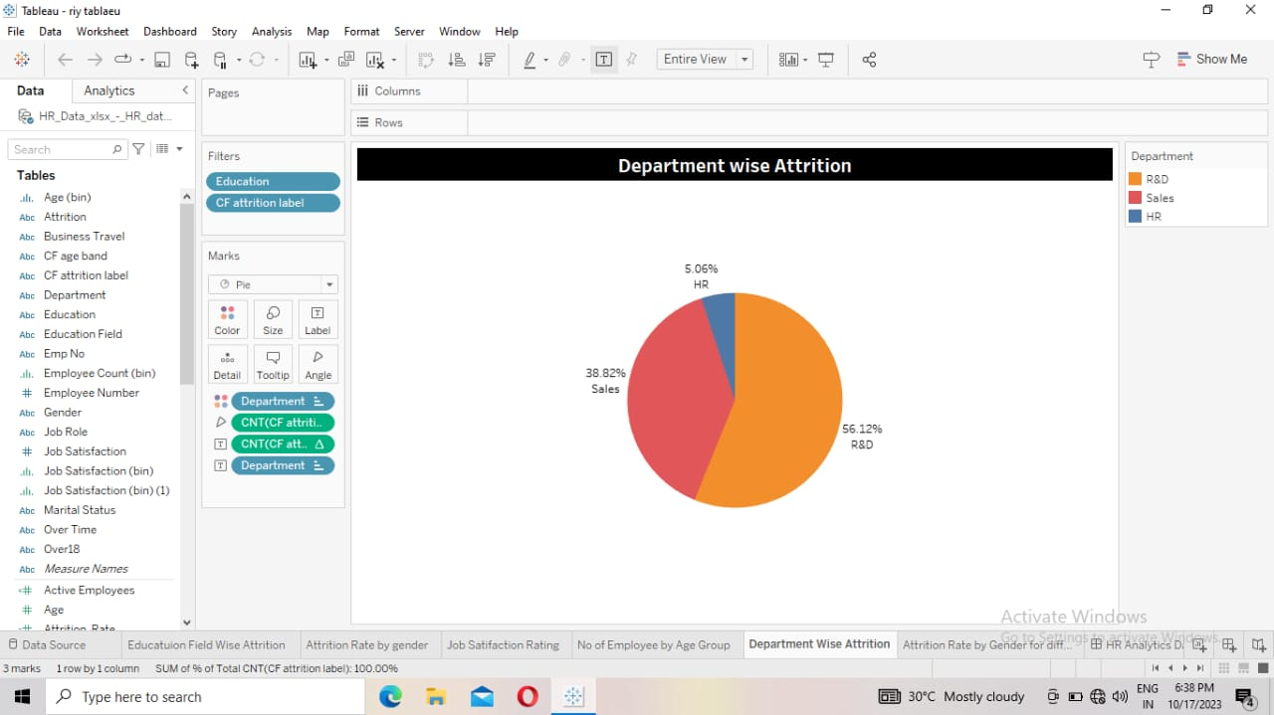

* Go to sheet 1.
* Drag education to filter.
* Drag department to color.
* Click marks to select the pie.
* Drag department to label.
* Drag attrition count to angle.
* Drag attrition count to label in percentage appear above.

**Explanation video link:**

<https://drive.google.com/file/d/1i6VArlJUEjJhqEfQOQEIgSqZs5WIfoIc/view?usp=share_link>

**Activity 1.2: No. of employees by Age Group**

* Go to sheet 2.
* Drag education to filter.
* Drag age (bin) to column.
* Drag sum (employee count) to row.
* Drag sum (employee count) to colour.
* Drag employee count to label.

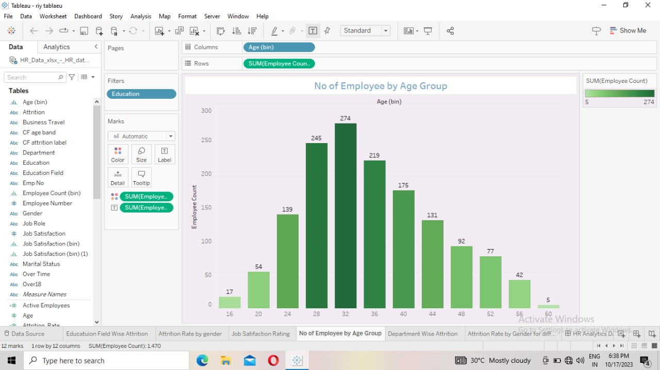

**Explanation video link:**

<https://drive.google.com/file/d/1doo4RxQEA4c7YF2Uh1bJJrpGalTbD6W3/view?usp=share_link>

**Activity 1.3: Job Satisfaction Rating**

* Go to sheet 3.
* Drag job satisfaction to column.
* Drag job role to row.

You change the squares.

* Drag the sum (employee count) to label.

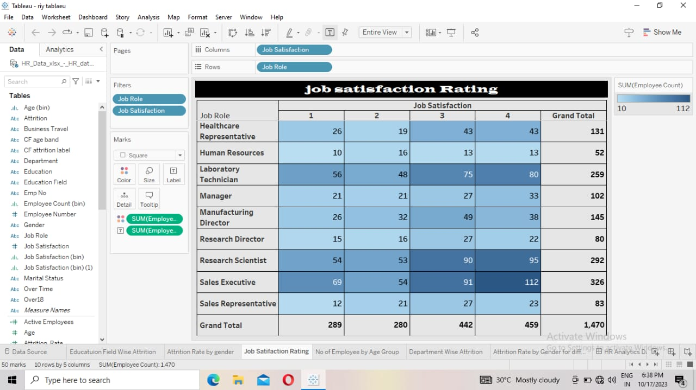

**Explanation video link:**

<https://drive.google.com/file/d/1xX3HU7rMstuM5tf9VcSsVRH_zoeSdxxr/view?usp=share_link>

**Activity 1.4:**

**Education Field wise Attrition**

* Go to sheet 4.
* Drag education to filter.
* Drag sum (attrition count) to column.
* Drag education field to row.
* Drag sum (Attrition count) to label.

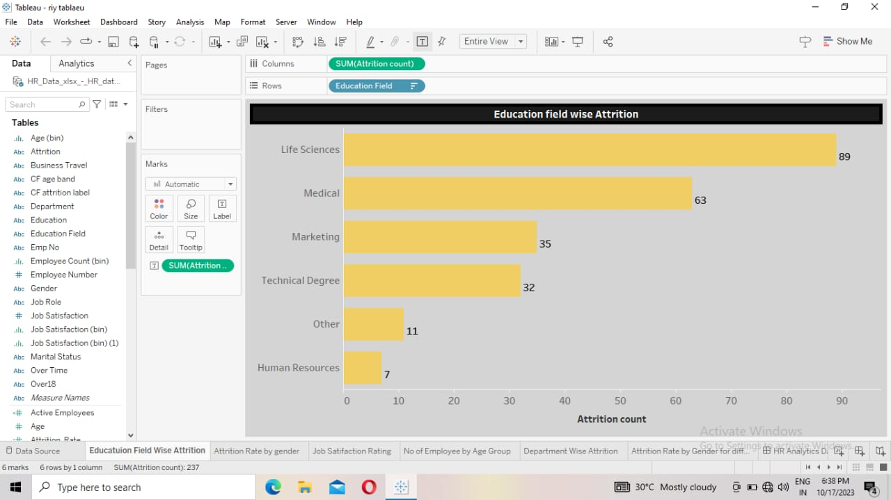

**Activity 1.5:**

* Go to sheet 5
* Your drag sum (Employee count), sum (Attrition count), average (Attrition rate), sum (Active employee), average (age) to rows.

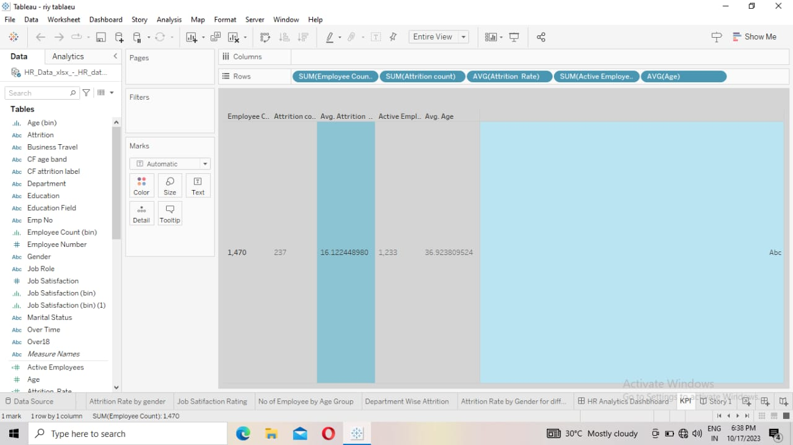

**Activity 1.6**

**Attrition by Gender**

* Go to sheet 6
* Drag education to filter.
* Drag attrition count to column.
* Drag Gender to row.
* Drag attrition count to label.

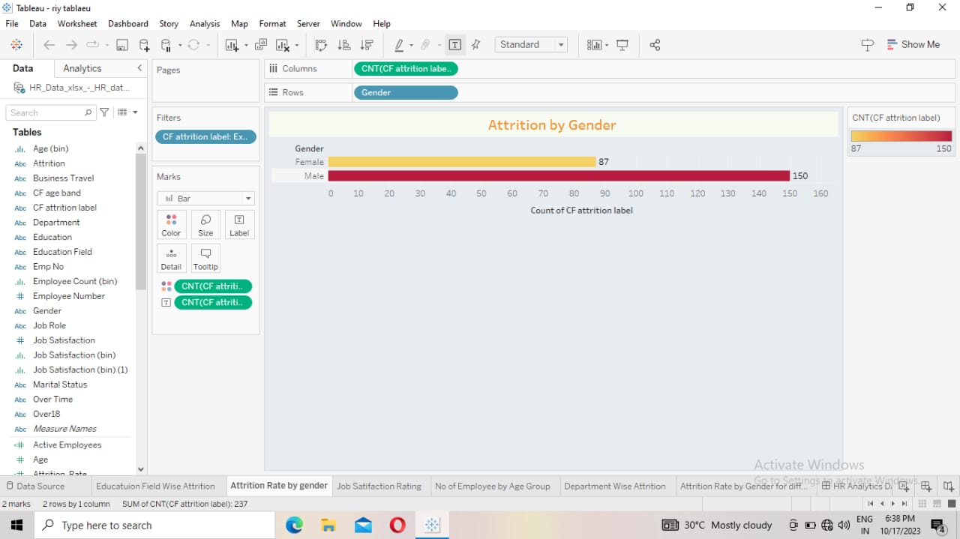

**Activity 1.7**

**Attrition Rate by Gender for Different age group**

* Go to sheet 7
* Drag CF age band to columns.
* Drag CF attrition label to filter
* Drag CF attrition label to row.
* Drag gender to colour.
* Click marks select pie.
* You type AGG(AVG(0)) to row.
* Type again AGG(AVG(0)) to row.
* Click Dual axis in AGG(AVG(0)).
* The pie chart is merged.
* Click marks, select second AGG(AVG(0)), Clear the all.
* Increase size for first AGG(AVG(0)). Decrease size of second AGG(AVG(0)).
* Donut pie chart will be created

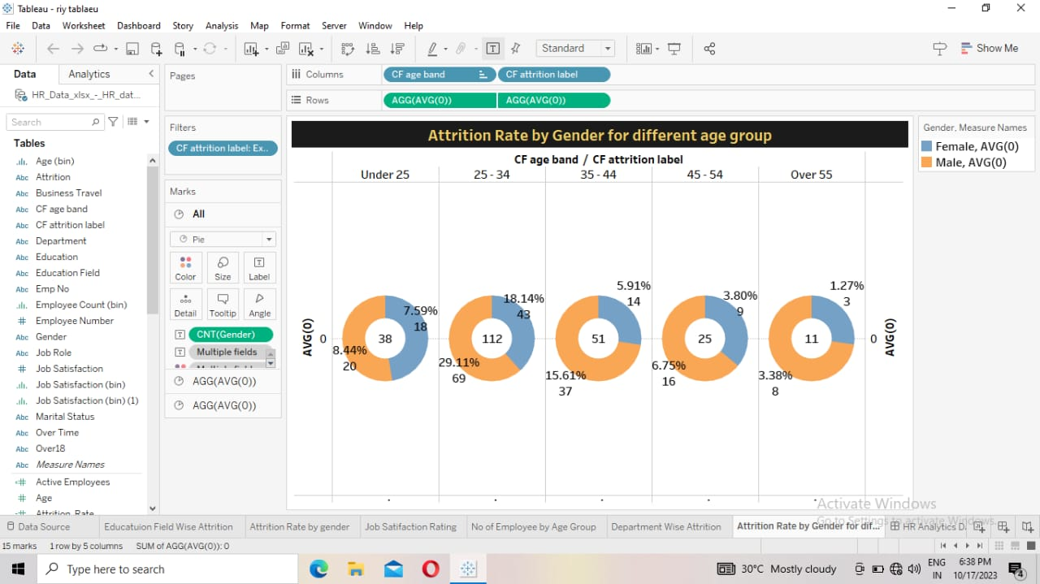

MILESTONE 5:

DASHBOARD:

A dashboard is a graphical user interface (GUI) that displays information and data in an organized, easy-to-read format. Dashboards are often used to provide realtime monitoring and analysis of data, and are typically designed for a specific purpose or use case. Dashboards can be used in a variety of settings, such as business, finance, manufacturing, healthcare, and many other industries. They can be used to track key performance indicators (KPIs), monitor performance metrics, and display data in the form of charts, graphs, and tables.

Activity 1:

DASHBOARD:

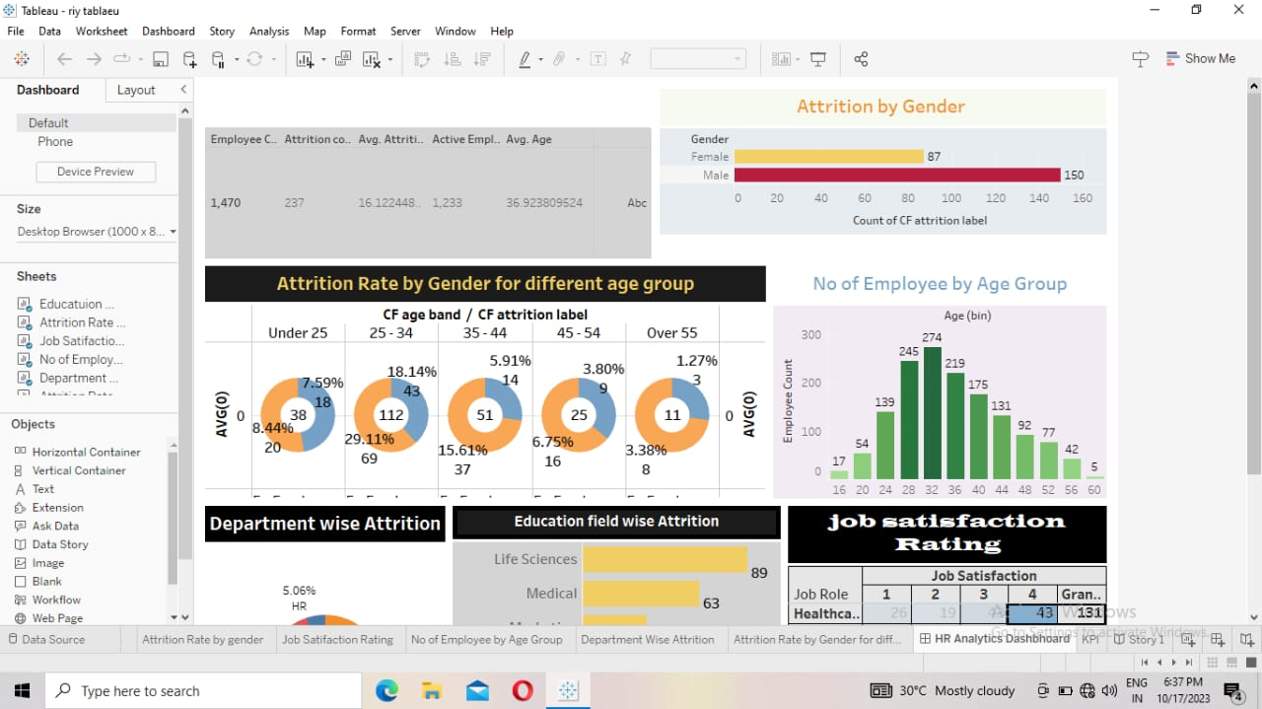

DASHBOARD LINK:

<https://public.tableau.com/views/Dashboard1_16957180038890/Dashboard1?:language=enGB&publish=yes&:display_count=n&:origin=viz_share_link>

MILESTONE 6:

STORY:

A data story is a way of presenting data and analysis in a narrative format, with the goal of making the information more engaging and easier to understand. A data story typically includes a clear introduction that sets the stage and explains the context for the data, a body that presents the data and analysis in a logical and systematic way, and a conclusion that summarizes the key findings and highlights their implications. Data stories can be told using a variety of mediums, such as reports, presentations, interactive visualizations, and videos.

Activity 1: No of Scenes of Story

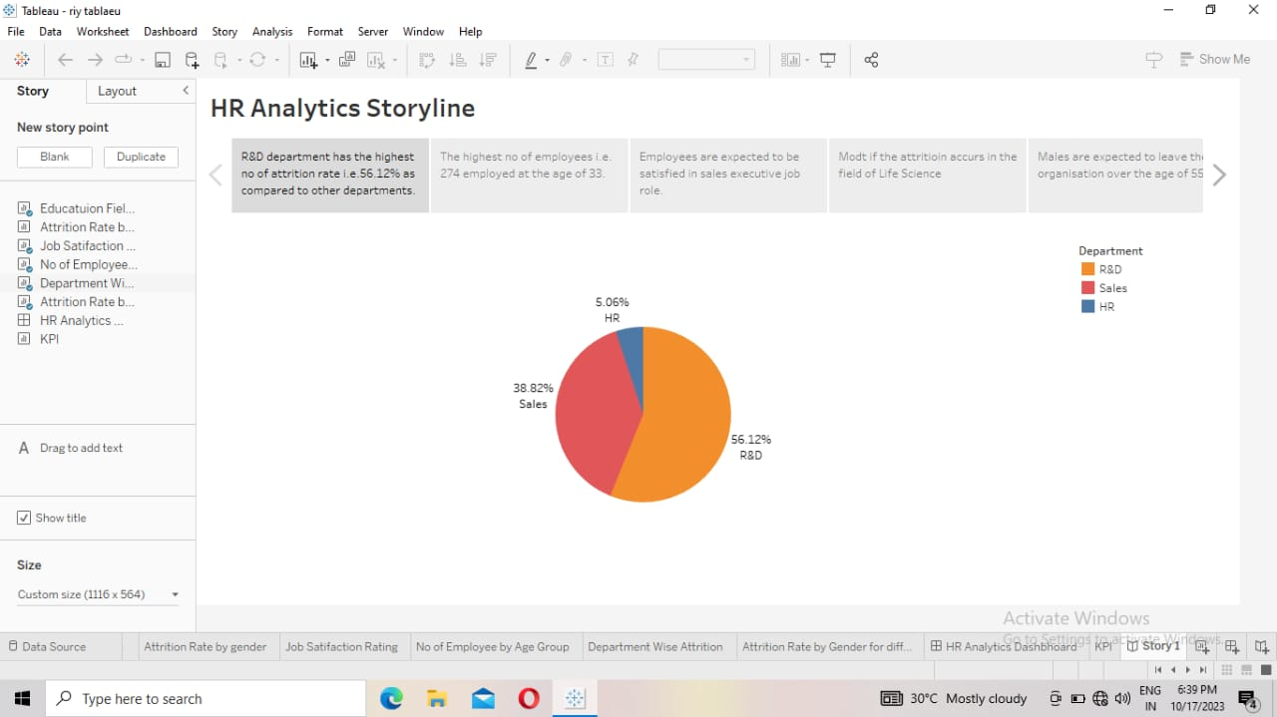

Story link:

<https://public.tableau.com/views/Story1_16957192526880/Story1?:language=enUS&publish=yes&:display_count=n&:origin=viz_share_link>

**MILESTONE 7:**

**Performance Testing**

**Activity 1:**

**Utilization of Data Filters**



**Activity 2:**

**No of Calculation Fields**

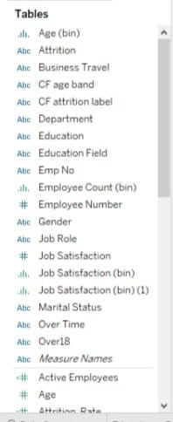

**Activity 3:**

**No of Visualizations/ Graphs**

1. KPI

2. Department wise Attrition

3. No. of employees by Age Group

4. Job Satisfaction Rating

5. Education Field wise Attrition

6. Attrition Rate by Gender for different age group

**Milestone 8: Publishing**

**Team Leader:** [**https://public.tableau.com/app/profile/selvaraj.m4029/vizzes**](https://public.tableau.com/app/profile/selvaraj.m4029/vizzes)

**Team Member 1:** [**https://public.tableau.com/app/profile/selvaraj.m4029/vizzes**](https://public.tableau.com/app/profile/selvaraj.m4029/vizzes)

**Team Member 2:** [**https://public.tableau.com/app/profile/selvaraj.m4029/vizzes**](https://public.tableau.com/app/profile/selvaraj.m4029/vizzes)

**Team Member 3:** [**https://public.tableau.com/app/profile/selvaraj.m4029/vizzes**](https://public.tableau.com/app/profile/selvaraj.m4029/vizzes)

**Team Member 4:** [**https://public.tableau.com/app/profile/selvaraj.m4029/vizzes**](https://public.tableau.com/app/profile/selvaraj.m4029/vizzes)

**ADVANTAGES:**

1. **Data-Driven Decisions**: It provides data and insights to make informed decisions about talent acquisition, development, and retention strategies.
2. **Performance Improvement**: Helps in identifying areas for improvement, leading to more effective talent management practices.
3. **Objective Evaluation**: Enables an objective assessment of employees and talent management processes, reducing biases.
4. **Resource Optimization**: Ensures that resources are allocated efficiently, focusing on high-impact initiatives.
5. **Strategic Alignment**: Aligns talent management efforts with the organization's strategic goals, enhancing overall performance.
6. **Talent Development**: Identifies high-potential individuals, facilitating their development and career growth.
7. **Succession Planning**: Assists in identifying and grooming future leaders and key contributors within the organization.
8. **Competitive Advantage**: Improves an organization's competitiveness by attracting, retaining, and developing top talent.
9. **Legal Compliance**: Helps in adhering to legal and ethical standards in talent management, reducing legal risks.
10. **Employee Engagement**: Enhances employee satisfaction and engagement by focusing on their development and career progression.
11. **Adaptability**: Allows organizations to adapt to changing market conditions and evolving industry demands by having the right talent in place.
12. **Long-Term Sustainability**: Contributes to the long-term sustainability and growth of the organization by ensuring a capable workforce.

In summary, measuring success in talent management enables organizations to be more efficient, strategic, and competitive in today's dynamic business environment.

**DISADVANTAGE:**

1. **Data Overload**: Gathering and analyzing data for talent management can be time-consuming and may lead to information overload, making it challenging to focus on critical insights.
2. **Costly and Resource-Intensive**: Establishing measurement systems and conducting assessments can be expensive and resource-intensive, especially for small businesses.
3. **Misinterpretation**: Inaccurate or misinterpreted data can lead to misguided decisions and actions, potentially harming talent management efforts.
4. **Resistance to Metrics**: Employees may resist being reduced to metrics, feeling devalued or manipulated by measurement systems.
5. **Short-Term Focus**: Overemphasis on short-term goals may neglect long-term talent development and succession planning.
6. **Risk of Biases:** Data collection and analysis can be influenced by biases, which can lead to unfair evaluations and decisions.
7. **Privacy Concerns**: Collecting and using personal data for talent management may raise privacy concerns and compliance issues, especially with data protection regulations.
8. **Stifling Creativity**: Overly rigid metrics can discourage creativity and innovation, as employees may focus on meeting specific targets rather than exploring new ideas.
9. **One-Size-Fits-All Approach**: Using uniform metrics may not account for individual or team differences, potentially limiting the effectiveness of talent management strategies.
10. **Demotivation:** Excessive monitoring and evaluation can demotivate employees if they perceive it as micromanagement or lack of trust.

To mitigate these disadvantages, organizations should carefully design their talent management measurement systems, balance quantitative data with qualitative insights, and ensure that measurements align with their overall strategic goals and values.

**CONCLUSION:**

In conclusion, Talent Management Metrics are essential in that they provide organizations with the ability to measure their performance in critical areas such as recruitment, training and Development, performance management, employee engagement, retention and diversity and inclusion, thus making data-driven decisions.

**MILESTONE 9:**

**PROJECT DEMONSTRATION & DOUMENTATION**

**LINK:**

[**https://drive.google.com/file/d/1G6a3xcZ5ZTNUAOnpxSFB82hvsO6VVsRI/view?usp=drivesdk**](https://drive.google.com/file/d/1G6a3xcZ5ZTNUAOnpxSFB82hvsO6VVsRI/view?usp=drivesdk)